51. Šalamunov memorial 2018

Maribor, Slovenia

October 19th – 21st, 2018
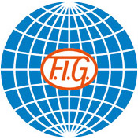
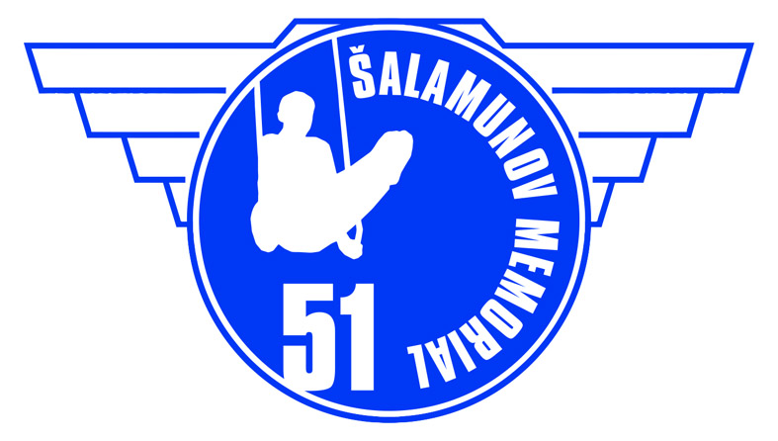

Form to be sent to:
Organizing Committee
Društvo za šport in rekreacijo Železničar Maribor
Cesta zmage 90, 2000 Maribor
Contact person: Jerneja Fišer Kurnik
Phone: +386 40 574 534
Fax: +386 2 720 86 10
E-mail: gimnastika.salamun@gmail.com
www.salamunov-memorial.si
Deadline: September 10th 2018

Nominative registration

Federation / Club |  | Contact person:
Federation / Club |  | Phone:
Federation / Club |  | E-mail:
Club:

Gymnasts: WAG (Juniors)
WAG | Name | Date of birth | Apparatus | Licence Number
1
2
3
4
5
6

Gymnasts: WAG (Seniors)
WAG | Name | Date of birth | Apparatus | Licence Number
1
2
3
4
5
6

Gymnasts: MAG (Juniors)
WAG | Name | Date of birth | Apparatus | Licence Number
1
2
3
4
5
6

Gymnasts: MAG (Seniors)
WAG | Name | Date of birth | Apparatus | Licence Number
1
2
3
4
5
6

Coaches:
Name: (male/female)
Name: (male/female)
Name: (male/female)
Name: (male/female)

Judges:
Name: (male/female) ID number:
Name: (male/female) ID number:
Name: (male/female) ID number:
Name: (male/female) ID number:

Extra persons:
Name: position in the team: (male/female)
Name: position in the team: (male/female)

Place and date | Seal of the NF | NF authorised signature
 |  | Signature of the President or Secretary General of the participating FIG affiliated NF

